Lessons From the field

NARTIS TRAINING

1 INTRODUCTION
Nurse-led ART Initiation began in Swaziland as a result of the need to scale up access to treatment, particularly in response to the changing guidelines in 2010 which increase treatment eligibility threshold from CD4<200 to CD4<350. This change in guidelines meant that higher number of clients will need to be initiated on treatment, and the number of Medical Officers within the Nation Program would not have matched the additional number of clients needing ART – without the undesirable recuse to waiting list. This need to put more people on treatment gave ever-increasing weight to the importance of decentralization generally, and in particular, the involvement of Nurses in ART Initiation. NARTIS is one of the primary strategy adopted to bring ART services to rural clinic and ensure PLHIV have easy access to HIV services closer to their homes.
On the 4th to the 11th of March 2016 the Nurse-led ART Initiation training conducted a training at the Lubombo region in Siteki Hotel. Thematic Areas was Unit – HIV management and the training providers were URC and SNAP whereby URC was the supporting partner. The trainer was DR Pasipamire. The NARTIS training was for the state registered nurses having basic IMAI qualification and some experience in ART Refill.

2 APPROACH
Training curriculum were used, each day trainers were there facilitating the necessary information that participants need to know about ART, inter-active slides presentation by different presenters were made each day, and by the end of business participants were normally given case studies to work on, pre-test and later on Friday post – test was given to the participants to assess whether during the training were able to get or to learn and lately evaluation tools were used.

3 TRAINING OVERVIEW
NARTIS training is a five day interactive classroom-based and content focus training followed by a five day supervised clinical practicum to capacitate nurses in ART initiation. The training is focus on providing trainees with in-depth knowledge on patient history taking and examination of the various systems and practical skills on decision making for ART initiation. The training lasted for a week and it was conducted at Siteki Hotel to enable nurses to initiate ART. The training was supported by URC and SNAP. A number of participants were trained and later given clinical attachment logbook and were also allocated to facilities where they will be starting their duties on the 21st of March 2016.
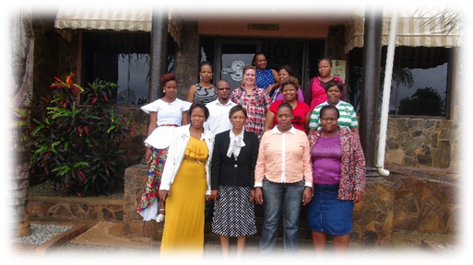
Participant’s group photo

4 TRAINING OBJECTIVES
The overall training objectives was to enable the state registered nurses to confidently prepare, initiate and monitor ART treatment in adults, pregnant women, adolescents and children to help stable HIV patients.

4.1 TRAINING METHODS
Different training method were implemented during the NARTIS training process. Normally the training methods are divided into two major category which are classroom methods and during clinical Attachment. Under classroom methods there were case studies that were usually done at the end of each class, group work were conducted were groups come together to discuss certain topics, inter-active PowerPoints presentations made by certain trainers which were the coordinator Dr Pasi, Yvonne, Phetsile and Dr Victor to name a few. Lastly for course evaluation participants were given Pre-and post-test knowledge assessments, course evaluation and clinical attachment logbook to assess and evaluate and usefulness of course.

Trainees listening to presentation made by Victoria on Human Rights and ethical issues with HIV
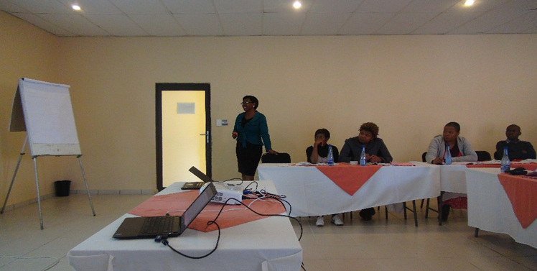

5 KEY OUTPUTS
At the end of the training participants need to demonstrate knowledge and practical skills in preparing patients for ART initiation, including taking proper history: focus examination of patients; conduct and interpret baseline test and pre-ART adherence counselling. Further demonstrate knowledge and practical skills on monitoring patients on antiretroviral, also help identify complicated cases and understand when to consult medical officer or to refer appropriately to a higher level.

5.1 PARTICIPATION
The participants of the training were mainly state registered nurses, improvement advisors, senior clinical advisors with previous experience in ART refills under the Lubombo region and the trainers were Dr Munyaradzi Pasipamire who was the coordinator and organizer of the NARTIS training, and others were Dr Victor, Dr Arnold, Dr Yohannes, Yvonne, Victoria, Hugben, Dr Masango, and Sandile.

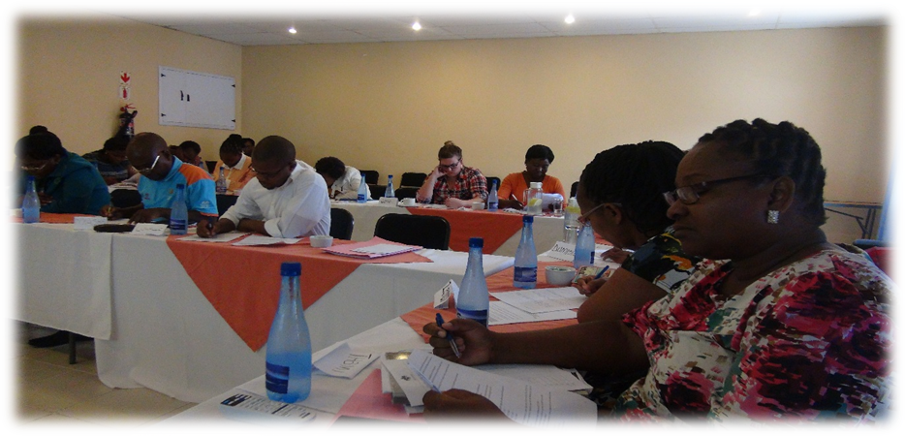Participants writing post-test

6. TRAINING OUTCOMES
One in the participants Q.E Mvila have highlighted that the training will benefits community help reduce disease burden, further it will enable early initiation of ART nearest facility cost effective, adherence emphasized. She further mentioned that facilitators were excellent, timely however there is a need to include skin disease in the training. Quality improvement, assurance and institution of infection prevention measures for HCW and clients should be considered.
In addition another participants mentioned that the training was very informative it will help them in initiating ART and provide quality care to patents. It was beneficial we get answers about prevailing questions we have concerning TB/HIV. She elaborate that presentations were good, facilitators knowledgeable and slides were clear however in future they have to start with the complex presentations in the morning. Another participants mentioned that the number of case studies in class should be increase so to gain confidence.

LESSON LEARNED
- Participants were happy on how the training was conducted they were so confident and interactive.
- Trainees did have previous experience in ART since all of them did pass the pre-test.
- Training was very crucial it help benefits participants and also give them insight on the initiation of ART.
- Training was a success because all of the participants pass the post-test and the overall mark of the post-test was 88.8 showing a steady increase from the pre-test which was 66.4.

